**ACKNOWLEDGEMENT**

**PRACTICAL EXERCISE-1**

**Q: Write a program to find the factorial**

**PROGRAM: -**

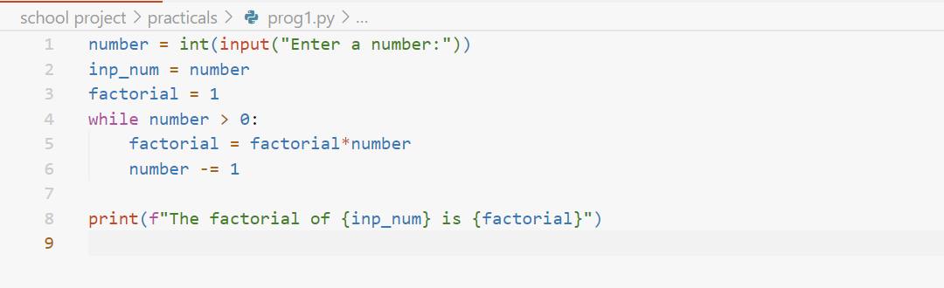

**OUTPUT: -**

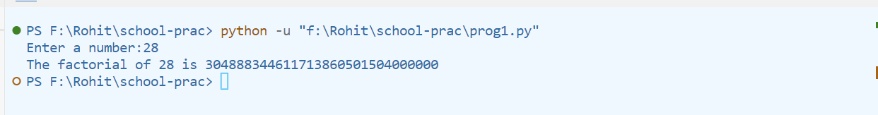

**PRACTICAL EXERCISE-2**

**Q: Write a program to check if a number is prime or not prime**

**PROGRAM: -**

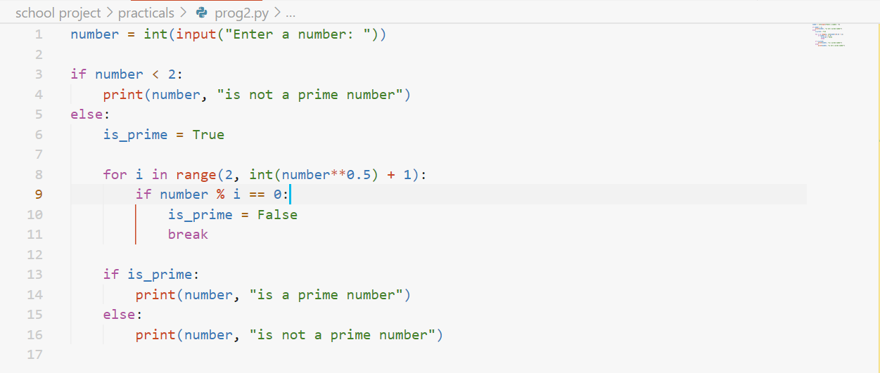

**OUTPUT: -**

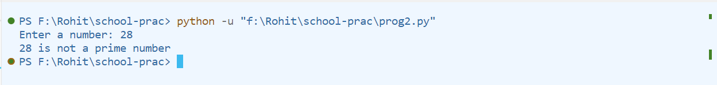

**PRACTICAL EXERCISE-3**

**Q: Write a program to find the sum of a list recursively**

**PROGRAM: -**

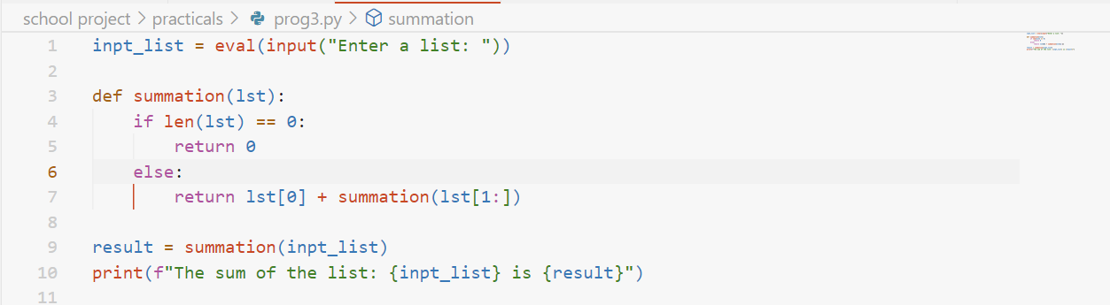

**OUTPUT: -**

